1. Solution Architecture

1.1 Overview
The proposed solution is designed following Salesforce Well-Architected principles by separating presentation, orchestration, business logic, integration, and data persistence into independent layers.
The solution leverages Salesforce Experience Cloud as the citizen-facing portal, Lightning Web Components (LWC) for the user interface, Flow for declarative orchestration, Apex for complex business logic and integrations, and Custom Metadata Types to support configurable business rules.
The architecture follows the principle of using declarative capabilities whenever possible while reserving Apex for scenarios requiring complex calculations, reusable business logic, or performance-critical processing.

1.2 Architecture Principles
The solution is designed based on the following principles.
Principle | Implementation
Configuration over Customization | Business rules are stored in Custom Metadata Types whenever possible.
Separation of Concerns | UI, orchestration, business logic, integration, and persistence are implemented independently.
Reusability | Business services are implemented as reusable Apex service classes.
Scalability | Business logic is bulkified and designed for large-volume processing.
Security by Design | Named Credentials, Sharing Model, Permission Sets, and Experience Cloud Profiles are used.
Maintainability | Simple automation uses Flow while complex logic is implemented in Apex.

1.3 High-Level Solution Architecture

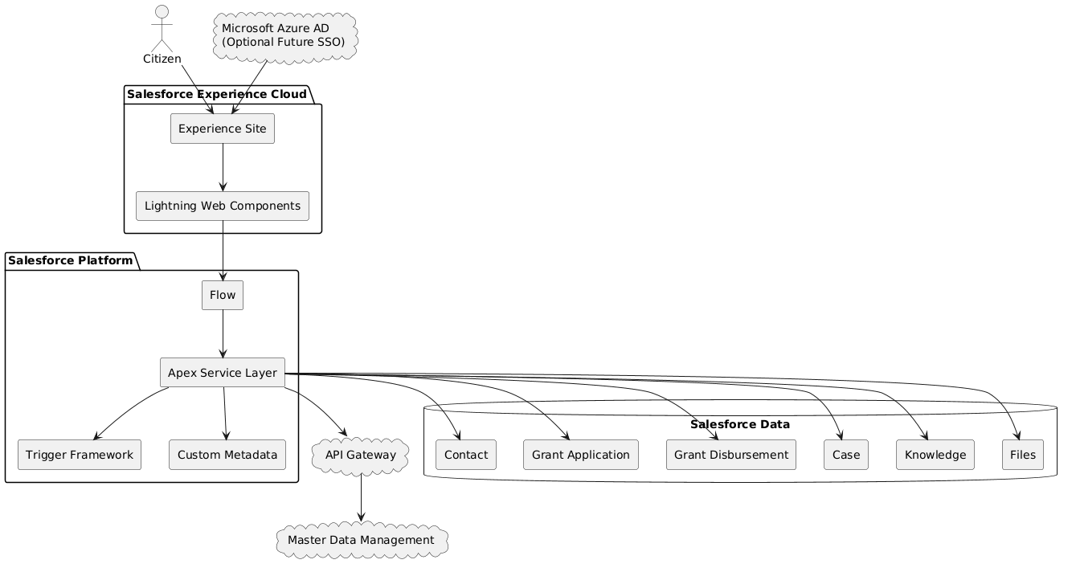

1.4 Architecture Reasoning
The architecture separates each responsibility into an independent layer.
Experience Cloud provides the public-facing portal for citizens.
Lightning Web Components are responsible only for user experience, client-side validation, and request submission.
Flow orchestrates declarative processes such as notifications, routing, and simple business automation. This allows administrators to modify business processes without requiring code deployment.
Complex business logic, integrations, grant calculations, redistribution algorithms, and bulk processing are implemented within Apex Service Classes. This improves testability, scalability, and maintainability.
Business configuration such as grant options, eligibility thresholds, and future support schemes are externalized into Custom Metadata Types instead of hardcoded Apex logic.
External systems are integrated through Named Credentials and REST APIs to provide secure authentication while avoiding hardcoded credentials.

1.5 Layered Architecture

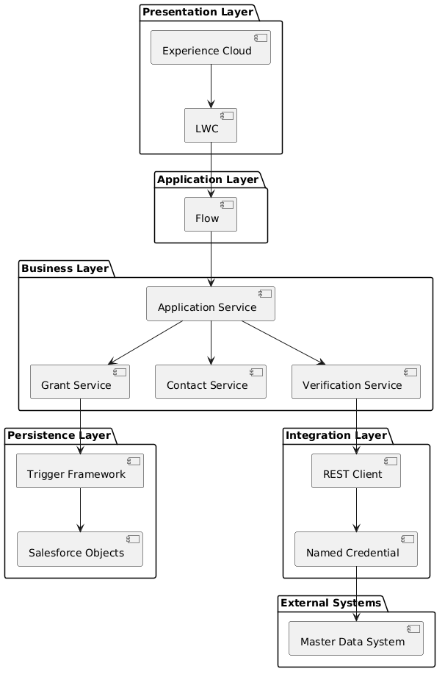

1.6 Why Flow Instead of Apex?
The solution intentionally follows a declarative-first architecture.
Flow is used for:
- Record orchestration
- Notifications
- Approval routing
- Assignment
- Simple business automation
Apex is reserved for:
- Complex grant calculations
- Redistribution logic
- External REST integrations
- Bulk upload processing
- Performance-critical algorithms
- Reusable enterprise services
This design minimizes technical debt while ensuring future maintainability.

1.7 Service Layer Design
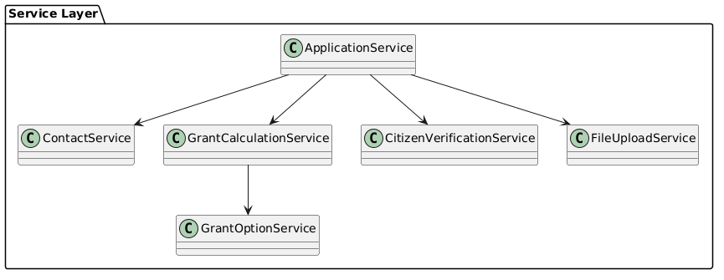

1.8 Business Flow
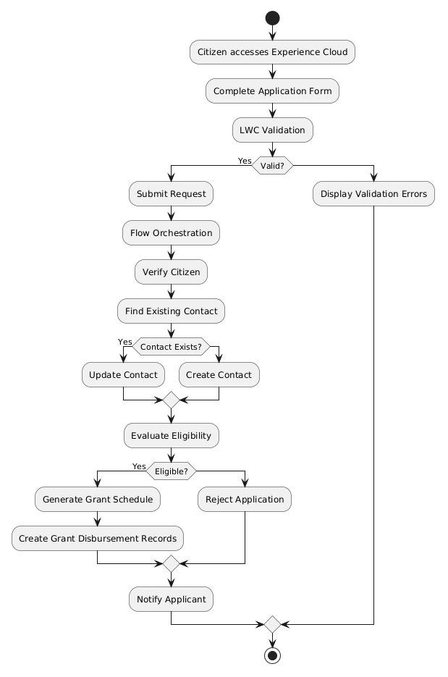

1.9. Scope

In Scope
This solution addresses the functional and technical requirements described in the GovTech Technical Assessment.
The proposed solution includes:
- Citizen self-service application through Experience Cloud.
- Grant application submission using Lightning Web Components.
- Contact management.
- Grant application management.
- Grant disbursement schedule generation.
- Eligibility validation.
- Integration with the external Master Data Management (MDM) system.
- Document upload using Salesforce Files.
- Administrator-configurable grant options using Custom Metadata Types.
- Centralized exception handling and operational monitoring.
- Security architecture based on Salesforce security best practices.
- Solution Architecture documentation.

Out of Scope
The following items are intentionally excluded from this assessment because they are outside the stated business requirements.
- Payment gateway implementation.
- Identity Provider (SSO) implementation.
- Infrastructure provisioning.
- CI/CD pipeline implementation.
- Monitoring platform implementation.
- Salesforce environment strategy.
- License estimation.
- Disaster recovery implementation.
- Production deployment planning.
- External financial system implementation.
- Data migration from legacy systems.
- Performance testing.
- User training.
- Operational support procedures.

2. Data Architecture

2.1 Overview
The proposed data model separates master data from transactional data to improve maintainability, scalability, reporting capability, and future extensibility.
Instead of storing all business information directly within the Contact object, the solution introduces a dedicated Grant Application object and Grant Disbursement object.
This approach enables multiple grant applications to be associated with a single citizen while preserving application history and supporting future business enhancements without modifying the core Contact record.

2.2 Entity Relationship Diagram
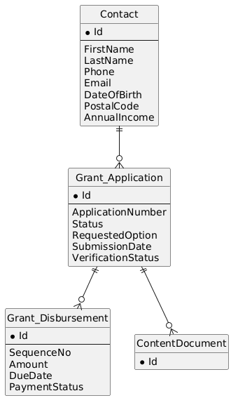

2.3 Data Ownership

Object | Purpose
Contact | Citizen master profile
Grant Application | Individual grant application
Grant Disbursement | Monthly payment schedule
Case | Citizen enquiries
Knowledge | Knowledge articles for support agents
ContentDocument | Uploaded supporting documents

2.4 Why Introduce Grant Application?
Although the requirement only requires Contact and Grant Disbursement records, introducing a Grant Application object significantly improves the overall architecture.
Benefits include:
- Separation between master data and transactional data.
- Preservation of application history.
- Support for multiple applications submitted by the same citizen.
- Improved reporting capabilities.
- Easier implementation of future business requirements.
- Better normalization of the data model.
This design aligns with enterprise CRM modeling practices.

2.5 Object Relationships
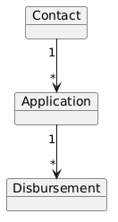

2.6 Application Lifecycle
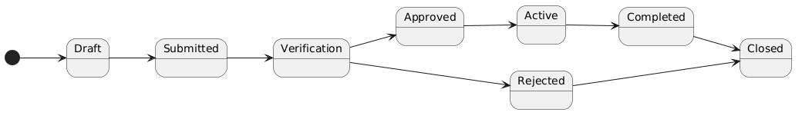

2.7 Grant Disbursement Lifecycle
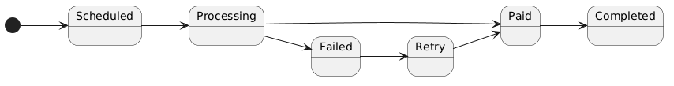

2.8 Data Validation Strategy
Data validation is implemented using multiple validation layers.
Layer | Responsibility
LWC | User experience validation
Validation Rules | Standard field validation
Apex | Cross-object validation and complex business rules
Trigger | Data integrity enforcement
Database | Referential integrity
The layered validation approach prevents invalid data from entering the system while providing immediate feedback to end users.

2.9 Configurable Business Rules
The solution avoids hardcoded business logic by externalizing configurable values into Custom Metadata Types.
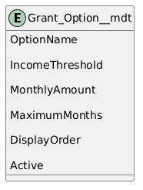
Administrators can introduce new grant schemes or modify existing configurations without requiring Apex code changes or deployments.

2.10 Future Scalability
The proposed data model supports future enhancements including:
- Multiple grant programs.
- Multiple applications per citizen.
- Additional verification stages.
- Appeals and reassessments.
- Payment integrations.
- Audit history.
- Government reporting.
- Historical grant analytics.
The architecture minimizes future schema changes while maintaining backward compatibility.

3. Application Architecture

3.1 Overview
The application layer is designed following the principles of loose coupling, high cohesion, and separation of responsibilities.
Business logic is encapsulated within reusable Apex service classes while Lightning Web Components (LWC) remain responsible only for user interaction and presentation.
Declarative automation is implemented using Salesforce Flow wherever appropriate, while Apex is reserved exclusively for complex processing that cannot be efficiently implemented using declarative tools.
This architecture minimizes technical debt while improving maintainability and long-term scalability.

3.2 Application Layer Overview
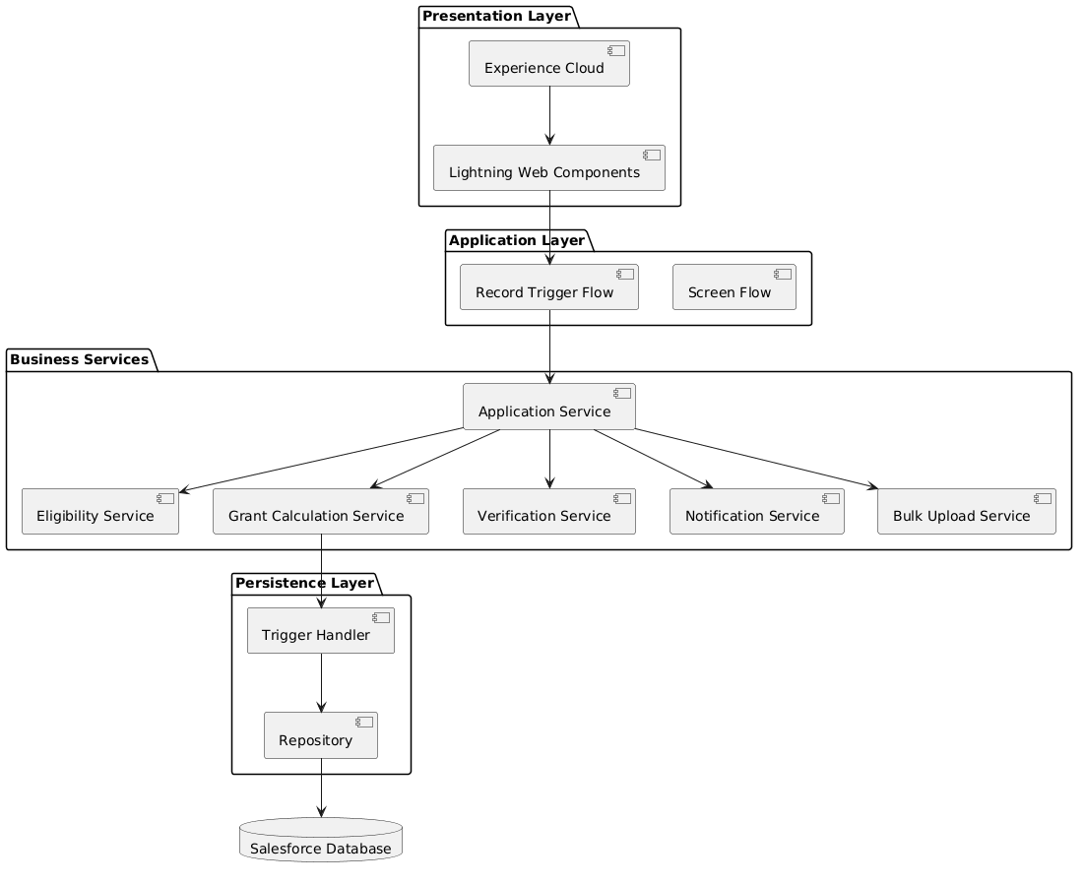

3.3 Business Service Responsibilities
Service | Responsibility
ApplicationService | Coordinates the complete grant application process
ContactService | Creates or updates citizen information
EligibilityService | Evaluates eligibility based on configurable business rules
GrantCalculationService | Calculates payment schedule and redistribution logic
VerificationService | Calls external citizen verification services
NotificationService | Sends email notifications and platform events
BulkUploadService | Processes CSV uploads using Batch Apex
GrantOptionService | Retrieves configurable grant options from Custom Metadata

3.4 Application Flow
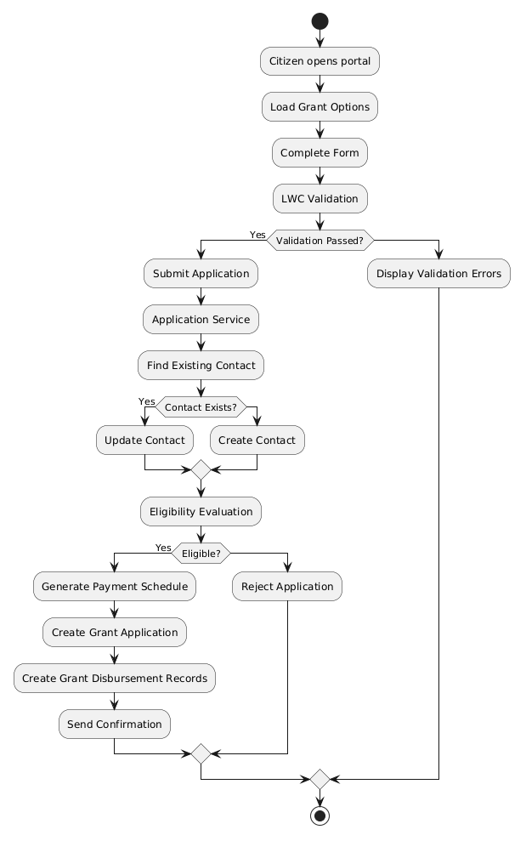

3.5 Flow vs Apex Decision Matrix
One of the key architectural decisions is determining whether a requirement should be implemented using Salesforce Flow or Apex.
Requirement | Technology | Justification
Email Notifications | Flow | Declarative, easy to maintain
Assignment Rules | Flow | Administrator configurable
Approval Process | Flow | Native Salesforce capability
Grant Eligibility | Apex | Complex business rules
Payment Redistribution | Apex | Performance-critical calculations
REST Integration | Apex | HTTP callouts are required
Bulk CSV Processing | Apex Batch | Large-volume processing
Complex Validation | Apex | Cross-object validation
Grant Option Retrieval | Custom Metadata + Apex | Configuration-driven solution

3.6 Why Apex Is Used Only When Necessary
The solution intentionally minimizes custom code.
Apex is implemented only when one or more of the following conditions are met:
- Complex payload transformation.
- Performance-critical calculations.
- External REST integrations.
- Bulk data processing.
- Cross-object business validation.
- Reusable enterprise services.
- Scenarios that cannot be implemented declaratively.
All other business automation is implemented using Salesforce Flow to reduce maintenance costs and improve administrator productivity. This approach follows Salesforce's recommendation to favor declarative capabilities before introducing custom code.

3.7 Service Interaction Diagram
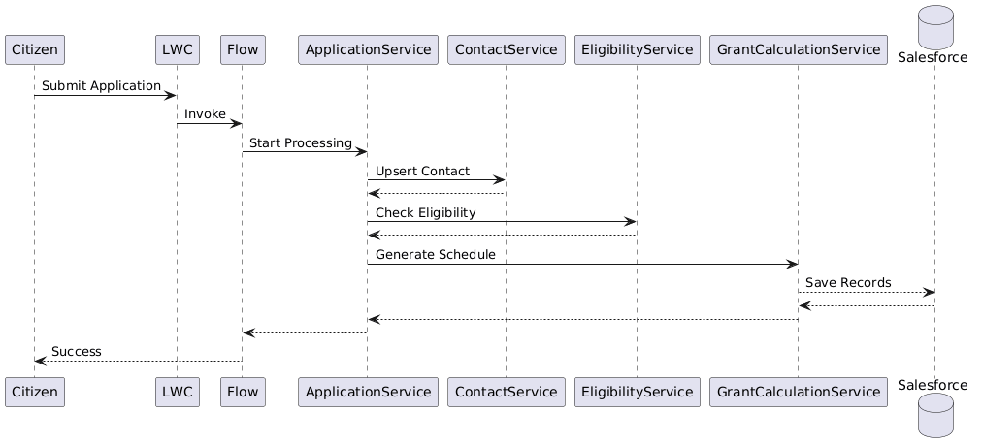

3.8 Error Handling Strategy
The application adopts a centralized error handling strategy.
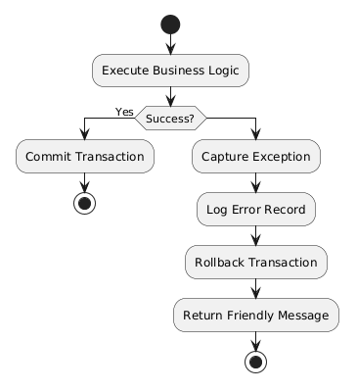
All exceptions are captured using a centralized exception framework.
Unexpected exceptions are stored in a dedicated custom object (Integration_Error__c or Application_Error__c) together with the following information:
- Timestamp
- User
- Transaction ID
- Request Payload
- Response Payload
- Stack Trace
- Retry Count
- Processing Status
This approach simplifies operational monitoring, troubleshooting, and future retry processing.

4. Architectural Decision Records (ADR)

4.1 Purpose
Architectural Decision Records (ADR) document the significant architectural decisions made throughout the solution design process.
Each decision captures the problem being addressed, the selected approach, alternative options considered, and the rationale behind the final decision.
This provides transparency, improves maintainability, and supports future architectural evolution.

ADR-001 — Introduce Grant Application as a Separate Transaction Object

Context
The assessment requires storing citizen information in the Contact object and grant payment schedules in Grant Disbursement records.
A design decision is required regarding whether all application-related information should be stored directly on Contact or separated into a dedicated transactional object.

Decision
Introduce a custom object named Grant_Application__c between Contact and Grant_Disbursement__c.

Alternatives Considered
Option | Description
Store all information directly in Contact | Simpler implementation but mixes master and transactional data
Introduce Grant Application object | Adds one object but provides a cleaner domain model

Rationale
Separating application data from citizen master data provides better normalization, preserves application history, supports multiple applications per citizen, improves reporting capabilities, and simplifies future enhancements.

Consequences
Positive:
- Better scalability
- Cleaner data model
- Easier maintenance
- Historical tracking
Trade-off:
- One additional custom object
- Slightly higher implementation complexity

ADR-002 — Flow First, Apex When Necessary

Context
Salesforce offers both declarative automation and programmatic development.
A design decision is required regarding where business logic should be implemented.

Decision
Use Salesforce Flow for orchestration and Apex only for complex business logic.

Rationale
Flow provides better maintainability for administrators and reduces long-term technical debt.
Apex is reserved for scenarios requiring:
- Complex calculations
- External integrations
- Bulk processing
- Performance-critical algorithms
- Cross-object validation

Consequences
Positive:
- Easier administration
- Lower maintenance cost
- Reduced custom code
- Better alignment with Salesforce best practices
Trade-off:
- Logic is distributed between Flow and Apex
- Clear governance is required

ADR-003 — Configuration over Hardcoded Business Rules

Context
The assessment explicitly states that administrators should be able to add new grant options without modifying source code.

Decision
Store grant configuration in Custom Metadata Types.

Alternatives Considered
Option | Description
Hardcoded Apex Constants | Requires deployment for every business change
Custom Metadata Type | Business configuration managed by administrators

Rationale
Business rules change more frequently than application logic.
Externalizing configuration enables administrators to manage grant options without requiring code deployment.

Consequences
Positive:
- No deployment required
- Better flexibility
- Easier administration
Trade-off:
- Slightly more complex initial implementation

ADR-004 — Layered Service Architecture

Context
Business logic could be implemented directly inside controllers or triggers.

Decision
Implement a dedicated Service Layer.

Rationale
Each service has a single responsibility.
Services are reusable across LWC, Flow, Batch Apex, Scheduled Apex, and REST APIs.

Consequences
Positive:
- High cohesion
- Loose coupling
- Easier unit testing
- Better scalability
Trade-off:
- Additional classes
- Slightly more project structure

ADR-005 — Trigger Handler Pattern

Context
Business logic can either be written directly inside triggers or delegated to handler classes.

Decision
Use a Trigger Handler framework.

Rationale
Triggers should only dispatch events.
Business logic belongs inside service classes.

Consequences
Positive:
- Cleaner triggers
- Reusable logic
- Easier testing
- Better governance
Trade-off:
- More Apex classes

ADR-006 — Named Credentials for External Integration

Context
Citizen verification requires communication with an external Master Data Management system.

Decision
Use Named Credentials together with External Credentials.

Alternatives Considered
Option | Description
Hardcoded endpoint and credentials | Security risk
Named Credentials | Secure and maintainable

Rationale
Authentication details are managed outside application code.
Credentials can be rotated without modifying Apex.

Consequences
Positive:
- Improved security
- Easier credential rotation
- Cleaner Apex code
Trade-off:
- Additional Salesforce configuration

ADR-007 — Centralized Error Logging

Context
External integrations and batch processing may fail unexpectedly.

Decision
Persist unexpected exceptions into a dedicated custom object.
Suggested object:
Application_Error__c
or
Integration_Error__c

Stored Information
- Timestamp
- User
- Transaction Id
- Error Code
- Error Message
- Stack Trace
- Request Payload
- Response Payload
- Retry Count
- Processing Status

Rationale
Centralized logging simplifies production support and enables retry mechanisms.

Consequences
Positive:
- Easier troubleshooting
- Operational monitoring
- Retry capability
- Audit history
Trade-off:
- Additional storage consumption

ADR-008 — Batch Apex for Bulk Processing

Context
The assessment requires processing bulk CSV uploads.

Decision
Use Batch Apex rather than synchronous processing.

Rationale
Batch Apex provides better governor limit management, fault isolation, and scalability.

Consequences
Positive:
- Handles large datasets
- Better resilience
- Supports partial retries
Trade-off:
- Slightly higher implementation complexity

ADR-009 — Enterprise Security Model

Context
The solution contains multiple user personas including Citizens, Support Agents, Supervisors, and Administrators.

Decision
Implement Salesforce's layered security model.

Components
- Organization-Wide Defaults (OWD)
- Role Hierarchy
- Sharing Rules
- Permission Sets
- Experience Cloud Profiles
- Field-Level Security
- Named Credentials

Rationale
Each layer addresses a different security concern, providing defense in depth.

Consequences
Positive:
- Least privilege access
- Regulatory compliance
- Simplified security governance
Trade-off:
- Additional configuration effort

ADR-010 — Salesforce Files Instead of Legacy Attachments

Context
The assessment requires applicants to upload supporting documents.

Decision
Store uploaded documents using Salesforce Files (ContentVersion, ContentDocument, and ContentDocumentLink).

Alternatives Considered
Option | Description
Attachment | Legacy feature with limited capabilities
Salesforce Files | Modern file management model

Rationale
Salesforce Files supports versioning, sharing, preview, and future integrations while aligning with Salesforce's strategic direction.

Consequences
Positive:
- Modern architecture
- Better file lifecycle management
- Native sharing and version control
Trade-off:
- Slightly more complex data model compared to legacy attachments

4.2 ADR Summary
The proposed architecture intentionally prioritizes maintainability, scalability, configurability, and operational excellence over short-term implementation simplicity. Each architectural decision has been evaluated based on long-term business value, Salesforce platform best practices, and enterprise application design principles. The result is a solution that not only satisfies the current assessment requirements but is also prepared to support future enhancements with minimal architectural rework.

5. Non-Functional Requirements

5.1 Overview
In addition to satisfying the functional requirements, the proposed solution is designed to meet key non-functional requirements related to performance, scalability, security, maintainability, reliability, and operational excellence.
These architectural considerations ensure that the solution remains sustainable throughout its lifecycle while supporting future business growth.

5.2 Performance
The application is designed to minimize server processing time and optimize the use of Salesforce platform resources.

Design Considerations
- Client-side validation is implemented using Lightning Web Components to reduce unnecessary server round trips.
- Business logic is bulkified to efficiently process multiple records within Salesforce governor limits.
- SOQL and DML operations are optimized to prevent excessive database operations.
- Collections (List, Set, and Map) are used to eliminate nested loops and reduce processing time.
- Long-running processes are executed asynchronously using Queueable Apex or Batch Apex where appropriate.
- External REST integrations are executed only when required to minimize network latency.

5.3 Scalability
The architecture supports future business growth without requiring major structural changes.

Design Considerations
- Separation between master data and transactional data.
- Configuration-driven business rules using Custom Metadata Types.
- Reusable Apex service classes.
- Layered application architecture.
- Batch processing for large-volume imports.
- Support for additional grant programs without changing application logic.
The proposed design allows new grant schemes, eligibility rules, and business configurations to be introduced through metadata rather than source code modifications.

5.4 Security
Security follows Salesforce's defense-in-depth approach.

Security Controls
- Organization-Wide Defaults
- Role Hierarchy
- Sharing Rules
- Permission Sets
- Field-Level Security
- Experience Cloud Profiles
- Named Credentials
- Secure REST authentication
- Platform Encryption (Future Enhancement)
Sensitive information is protected using Salesforce security mechanisms while external credentials remain outside application code.

5.5 Availability
The solution is designed for high availability by leveraging Salesforce Platform services.
External dependencies are isolated through REST integration layers.
Temporary failures from external systems do not impact overall platform availability and are handled through centralized exception management and retry mechanisms.

5.6 Reliability
The application incorporates several reliability mechanisms.
- Centralized exception handling
- Retry mechanism for integration failures
- Transaction rollback
- Validation before persistence
- Error logging
- Batch isolation for bulk processing
These mechanisms improve operational stability and simplify production support.

5.7 Maintainability
Maintainability is achieved through clear separation of responsibilities.
Presentation, orchestration, business logic, persistence, and integration are implemented independently.
Configuration is externalized into Custom Metadata whenever possible.
Simple automation uses Flow while complex reusable logic is implemented in Apex.
This minimizes technical debt while improving long-term maintainability.

5.8 Extensibility
The architecture is intentionally designed to support future enhancements.
Examples include:
- Additional grant schemes
- New eligibility rules
- Multiple payment providers
- Additional external integrations
- Mobile applications
- AI-assisted citizen support
- Government reporting platforms
These enhancements can be introduced with minimal impact on the existing architecture.

6. Assumptions and Constraints

6.1 Assumptions
The following assumptions have been made during the solution design.
ID | Assumption
A-01 | The Master Data Management (MDM) system exposes secure REST APIs for citizen verification.
A-02 | Each citizen can be uniquely identified using a government-issued identifier.
A-03 | Authentication for Experience Cloud users is managed through the organization's identity provider.
A-04 | Grant eligibility criteria are maintained by business administrators.
A-05 | Grant payment execution is performed by an external financial system.
A-06 | Business administrators are responsible for maintaining Custom Metadata records.
A-07 | Uploaded files comply with Salesforce storage limitations.
A-08 | External services provide acceptable response times for synchronous verification.

6.2 Constraints
The following technical constraints apply to the proposed solution.
ID | Constraint
C-01 | Salesforce governor limits apply to all Apex transactions.
C-02 | REST integrations depend on external system availability.
C-03 | File storage capacity is governed by Salesforce platform limits.
C-04 | Network latency may impact external API response time.
C-05 | Batch Apex execution follows Salesforce asynchronous processing limits.
C-06 | Platform upgrades and releases follow Salesforce release schedules.
C-07 | The assessment excludes implementation of payment gateway functionality.
C-08 | Infrastructure management is outside the scope of the Salesforce solution.

6.3 Design Trade-offs
Several architectural trade-offs were intentionally accepted.
Decision | Benefit | Trade-off
Introduce Grant Application object | Better normalization | Additional custom object
Use Flow for orchestration | Easier administration | Multiple automation technologies
Use Apex Service Layer | Better scalability | More implementation effort
Custom Metadata | Configuration-driven | Additional setup
Error Logging Framework | Better operational support | Increased storage usage

7. Risks and Mitigation

7.1 Overview
Every enterprise solution introduces technical and operational risks.
The proposed architecture includes mitigation strategies to reduce both the likelihood and impact of these risks.

7.2 Risk Register
Risk ID | Risk | Impact | Mitigation
R-01 | External verification service unavailable | Citizen verification cannot be completed | Retry mechanism, centralized error logging, manual verification process
R-02 | Duplicate citizen applications | Duplicate grant allocation | Duplicate Rules, Matching Rules, external verification
R-03 | Salesforce governor limit exceeded | Transaction failure | Bulkification, optimized SOQL, efficient collections
R-04 | Business rules change frequently | Frequent deployments | Store configuration in Custom Metadata
R-05 | Large CSV imports | Long processing time | Batch Apex
R-06 | Integration timeout | Delayed application processing | Timeout handling, retry queue
R-07 | Invalid uploaded documents | Application rejection | Client-side and server-side validation
R-08 | Unexpected Apex exception | Transaction rollback | Centralized exception framework
R-09 | Unauthorized data access | Security breach | Salesforce security model, least privilege principle
R-10 | Future grant scheme changes | High maintenance effort | Metadata-driven architecture

7.3 Operational Monitoring
The solution includes centralized operational monitoring.
Production incidents are captured using a dedicated error logging framework.
Captured information includes:
- Transaction Identifier
- Timestamp
- User
- Error Category
- Exception Message
- Stack Trace
- Request Payload
- Response Payload
- Retry Count
- Processing Status
Operational dashboards can be built using Salesforce Reports and Dashboards to monitor failed transactions and retry queues.

7.4 Retry Strategy
External integration failures are classified into retryable and non-retryable errors.
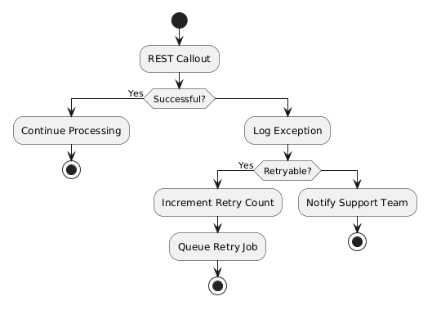
Retry attempts are limited to prevent infinite processing loops. Each retry updates the retry counter and processing status to provide complete operational visibility.

7.5 Disaster Recovery Considerations
The proposed solution relies on Salesforce Platform resilience and disaster recovery capabilities.
Additional operational recommendations include:
- Scheduled data exports
- Version-controlled source code repository
- Automated deployment pipeline
- Backup strategy for metadata
- Monitoring of integration endpoints
- Production alerting for failed integrations

